Geography P1
1.(a)
- mathematics principles formulae are used in Geography to calculate distance and population density
- Geography information can ge analyses and presented accurately through the application of mathematics
- Geography concepts are applied in calculating direction bearing in mathematics (2marks)
b)
- it helps to develop skills
- it enables learners to understand/appreciate different environmental influences
- it encourages international awareness/co-operation
- it helps learners to appreciate important social values
- it promotes positive attitudes towards protection of resources
- it leads to development of career opportunities
- it helps learners to manage time properly
- it enables learners to explain the origine and information of the earth and land forms
(4×1=4marks)
2.(a)- Moborovicic/moho
- Gutenburg (2×1=2marks)

( b)- outer core is composed of molten rock material
- it is made up of iron and nickel
- it is estimated to be about 2100km to 2890km
- it has temperature ranging from 3700⁰C to 500⁰C
- It has an average density of 10.0gm/cc to 12.3gm/cc 3×1=3marks
3. (a) – rain
Hails
Dew
Fog/mist (2marks)

(b) at a weather station
It is a white wooden box in which meteorological instruments are kept (2marks)

4(a)
- Magma movement within the crust
- Gravitational pull/gravitation pressure
- Convectional currents in the mantle
- Osostomatic adjustment any 2×1=2marks)
(b) (i) J hade
(ii) K block
L Fault scarp/escarpment
(5) (a)
- rainwater
Rivers
Underground water
Glacial melt water any 2×1=2marks

(b) most are narrow
Most are deep
Most are steep-sided
Most of them are salty
Most of them are long any 3×1=marks

6.(a) (i) –bridge call’s bridge
- all weather loose surface 2×1= 2marks

(ii)2362metres 2marks
(iii) Forest
Scrub
Woodland
Scattered trees
Riverine trees
Papyrus
Papyrus vegetation
Thicket any 3×1=3marks

(b) (i) 132⁰ (131-133) (2marks)

(ii) 12.ikm+0.1 (12.0-12.2) 2marks)

( c) (i)

(ii) – A dry weather road

- River kaptarit
- A ridge (3×1=3marks)
(iii)
VE=VS
HS
VE= 1 ÷ 1
4000 50,000
1 × 1
4000 50,000
=12½/12. Times (2marks)

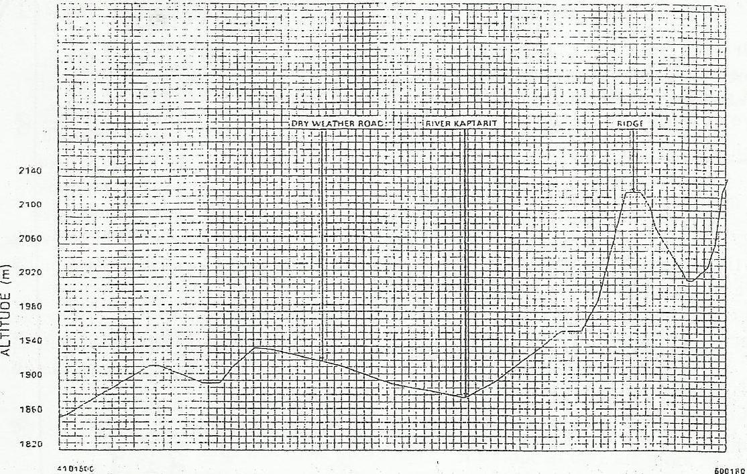

(d)
Service evidence
Health/ medical presence of hospital
Recreational services sports club/kitale club/Golf course
Religious service church
Security police station. DC’s
HOUSING Built-up areas/huts
Water supply water tower/tank
Burial services Cemetery any 5×1=5
7. (a) (i) mineral is an inorganic substance with a definite chemical compositon at a mine beneath the surface fo the earth
Is the solid inorganic substance occurring naturally (2marks)
(ii)
Lustre – minerals differ in the brightness depending on the nature of their reflective surfaces(smooth surfaces are shinny whereas rough surface are dull)
Colour – different minerals display different colours.
Density – minerals have different weight per unit volume of water
Minerals have different specific gravity/ some mineral are heavy while others are light (2marks)
(b) (i)
-Basalt -Rhyolite tephra
-pumice -obsidian phonolite
-Tuff -Andsite trachite
(ii) Mechanically formed sedimentary rocks fragments are transported wind/water. They are deposited in layers. Over a long period time. They are compacted into a hard rock.

Organically formed sedimentary rocks dissolved minerals of plants animals are deposited in layers. Over are then precipated/evaporated a long period of time, precipitates/evaporates are then compacted to form hard rock
3× 1=marks
( i) Tourism: some rocks form unique features that attract tourists earning the country foreign
exchange/income
(ii) Energy: Some sedimentary rocks contains fossil fuels which are sources of energy for domestic
for domestic/industrial use.
(iii) Water: Some rocks acts as storage for water which can be supplied for domestic
/industrial/agricultural
(8) a)(i) Hydration: in hydration certain rock minerals absorb water and expand. This causes internal stress in the rock and it eventually disintegrates
(ii) Oxidation : oxidation takes place in rocks that contain iron. The ion combines with oxygen forming iron oxides. Such rocks change colour and crumble easily.
(iii) Frost action
- In temperature/high mountains areas, water occupy service/cracks in the rocks during the day.
- At night temperature drops below freezing point causing the water to freeze and expand exerting pressure in the cracks
- The alternate freeze-thaw action weakens the rock causing it to disintegrate.
- During the day temperature rise causing the ice to melt thus releasing the pressure in the cracks
- Mentioned to score the maximum (6marks)

- (b) in arid/semi arid areas, there is large diurnal ranges of temperature
- During the day, a homogenous rock is intensely heated at night the rock looses heat rapidly
- The differential heating causes the outer layer to expand/contract faster than the inner layer.
- When this expansion and contraction takes place repeatedly, stress developed in the outer layer of rocks. Cracks appear on the surface layer
- Eventually, the outer layer peels off
- The peeling off leaves behind a rounded mass of rock known as exfoliation dome
(6marks)
© Nature of materials
Heavy and large materials move faster on a slope as they are more likely to be overcome by gravity thinly bedded layers have a tendency to move faster.
Angle of slope
-the steeper the slope, the faster the rate of movement/when rocks are dipping steeply, movement is faster.
Climatic factors/amount of water
-the more saturated the rock/soil/material is the more likely it is to move as water adds weitht and lubricants/alternate freezing and thawing encourages movement.
-bare surfaces are more likely to experience mass wastage because there is no vegetation to bind he materials together
Earth movements
-earth movements/ volcanic eruptions/isostatic adjustments cause vibrations which may trigger
widespread movement of weathered rock materials
(6marks)
- (d) (i) Mudslides/mudflow
- Earthflows/earthslide
- Landslides/stamping rock slide, rock fall debris sleep
(ii) telephone/fence poles that are inclined down a slope/bent tree trunks
- Accumulated soil at the soil at the foot of slope behind obstacles such as walls
- Existence of bare rock/exposed upper slope
- Presence of dipping rock strata in the direction of the slope
- Presence of overhanging banks above roads/rivers
- Presence of slope retreat (4marks)
9.(a)
- Direction of the slope of the land
- Difference in rock resistance hardness
- The arrangement of rocks layers
- Rock structure
- Faulting/fault guided
(ii)
The river has a steep river gradient
The river channel is narrow
The river has deep/steep-sided V-Shaped valley
The river flows at a high speed high stream velocity
The ventricle erosion/down cutting is dominant
The river channel is generally winding
Rapids/waterfall cataracts/cascades
Interlocking spurs/spot hole, plunge pools;
The type of flow is torrential
The river has a small volume of water
The river has as small load (5marks)
(b) (i) attrition: as rock materials are transported downstream, they constantly collide against each other
The materials gradually wear down/reduce in size
(ii) corrosion: as solid rock materials are transported downstream, they are hurled against the banks and dragged along the river bed
The rock materials/chip off pieces of rock form the channel and the river bed
The rock material scour/smoothen/grind the river bed
Eddy currents rotate pieces of rock around the hollow breaking grinding the river bed
(6marks)
(d)
- When rivers flood, they destroy, a lot of property/crops may displace people and may lead to human life
- Wide/deep rivers are a barrier to transport especially where bridges have not been constructed
- Rivers water can be a medium of spreading water-born disease, since flood water
Some rivers are habitat to dangerous animals which may attack human being/destroy crops
(d)
(i) Helps to asses suitability of study area
- It helps to draw up objectives/hypothesis for the study
- It helps to prepare route map
- It helps to design a working schedule
- It helps to identify the probable problems/how to solve problems
- Helps to estimate the cost of field study
- Helps to identify suitable data collection melting
- Appropriate equipment to be used during the field study
(ii) Measuring of gradient
- Finding out the nature of the load
- Finding out the amount of the load
- Establishing the velocity of the river
- Observing obstacles in the stream channel/distributaries
- Measuring of the width depth of the river. (3marks)
- (i)
It is a naturally occurring thin layer of loose/unconsolidated materials which overlies the crustal rocks and rocks and on which plants grow
It is any accumulation of the rock particles of minerals, organic matter and air found on the surface of the earth.
(ii) Nature of soil/solubility of minerals
- Nature of soil/solubility of minerals
- Amount of rainfall/alternating wet and dry season
- Nature of the slope
(b)
(i)parent rock
- The nature of rock influence the rate of weathering in the soft rock weather fast hard rock are resistant and weather slowly
The parent rock determines the solid texture in that large/coarse grained rock produce large /coarse grained rocks produce large/coarse grained solids.
The type of mineral in the parent rock are transferred to the solid during formation
(4marks)
(ii) Micro organisms in the soil assist in plant/animal decay to form humus
The micro organisms mix and aerate the soils
The roots of plants penetrate the soil enabling it to become porous
Ploughing/digging breakup rock structure form
When plants or animals die they decay to form humus organic matter in the soil.
(4marks)
© - the solid contain little or no humus
- The soils are of sandy into stormy texture
- The soil are sandy stony texture
- The soils are saline/contain………………..
- The solid lack moisture
- The solid may be light coloured
- The soil are thin shallow
- The soil are highly porous (3marks)

(ii) it is used as raw material in industries/pottery
- Glassmaking/brick making
- Soils support agriculture/development of forestry
- Some soils contain valuable minerals
- Some soils have medicine value
- It is used in building/construction
(d) rills/gullies/deep trenches
Lack of little vegetation
Little/absence of topsoil/thin soils
Exposed plant roots (2marks)

(ii) Photograph taking /video recording
Note taking
Field sketching
(iii) Construction of gabions
Construction of check dams
Afforestation/reaforestation
Filling in the gullies
Construction of drainage trenches
Practicing appropriate methods of farming/plant cover mulching/terraces/contour ploughing /strip planting /crop rotation
(3marks)

